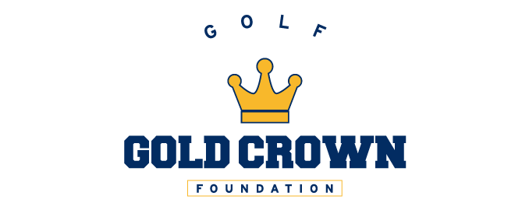

Lake Arbor Golf Course
Monday, April 11th 2022
8600 Wadsworth Blvd, Arvada, CO 80003
4:43 PM
Dylan King
Gavin King
Keaton Jackson
Owen Kohler
5:05 PM
Ashley Dinges
Iris Felix
Abby Andersen
Saya Neima
4:54 PM
Amelia Blevens
Mikayla Frank
Mariana Stavola
Bailey Webb
4:10 PM
Murphy Rowen
Oliver Rowen
Jake Cowin

4:21 PM
Zack Abdella
Max Wine
Will Rigney

4:32 PM
Trenton Nelson
Lucas Trujillo
Connor Travis
Jackson Travis

